

SUMMARY REPORT

Full time teachers sanctioned during the last five years
S. No | Academic Year | No of Full-Time Teachers
1 | 2022-23 | 48
2 | 2021-22 | 46
3 | 2020-21 | 46
4 | 2019-20 | 48
5 | 2018-19 | 42
TOTAL |  | 230

Total No.of full time teachers filled against sanctioned posts
S.NO. | Details | 2022-23 | 2021-22 | 2020-21 | 2019-20 | 2018-19 | Total
1 | Total no. of full-time teachers | 48 | 46 | 46 | 48 | 42 | 230
2 | Total no. of sanctioned posts | 48 | 46 | 46 | 48 | 42 | 230
Percentage of full time teachers against sanctioned posts during last five years : |  |  |  |  |  |  | 100%

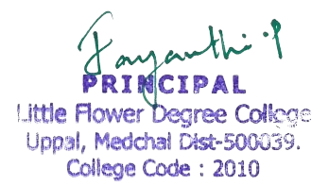

PRESENTATION TEMPLATE

S. No | Description | No. of Sanctioned posts | Link to the letter | No. of full-time teachers | Link to List of teachers
1 | Sanction letter indicating number of posts for A.Y.2022-23 | 48 | 2022-23 MOM | 48 | 2022-23 -Staff List
2 | Sanction letter indicating number of posts for A.Y.2021-22 | 46 | 2021-22 MOM | 46 | 2021-22 -Staff List
3 | Sanction letter indicating number of posts for A.Y.2020-21 | 46 | 2020-21 MOM | 46 | 2020-21 -Staff List
4 | Sanction letter indicating number of posts for A.Y.2019-20 | 48 | 2019-20 MOM | 48 | 2019-20 -Staff List
5 | Sanction letter indicating number of posts for A.Y.2018-19 | 42 | 2018-19 MOM | 42 | 2018-19 -Staff List

